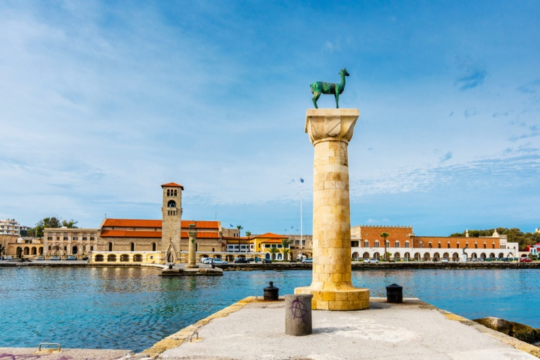
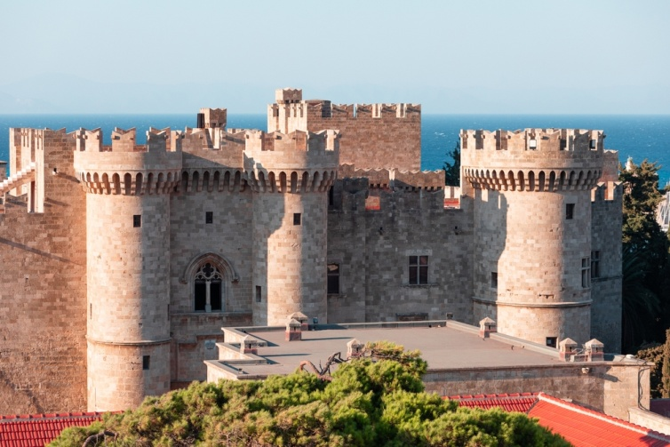
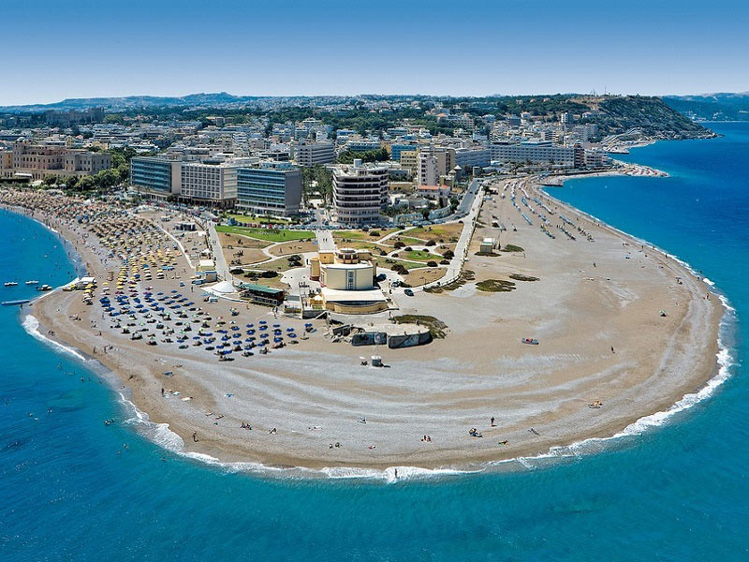
CONFERENCE PROGRAMME

Introduction
10 Top Reasons Why You Should Visit Rhodes Island, Greece in the context of our Conference!

1. Be mesmerized by the Gothic grandeur of the Old Town of Rhodes, one of the best-preserved medieval castle-states in the world and a UNESCO World Heritage City since 1988. The atmospheric Street of the Knights and the imposing Grand Master's Palace bring pages of a chivalric tale to life.
2. Enjoy the spectacular sight of the Valley of Butterflies, a habitat of unique natural beauty where thousands of colorful and rare butterflies find refuge from the coolness every summer.
3. Tour the majestic ancient acropolis of Rhodes on the hill of Monte Smith, overlooking the endless blue. The superbly restored Hellenistic stadium of Diagoras and the Temple of Pythian Apollo steal the impressions.
4. See the Rhodes of the Knights come to life before you at the annual Medieval Festival (early June), a three-day re-enactment of daily life in the Old Town during the time of the Order of Knights.
5. Discover the exotic Prasonisi, a pine-clad islet at the southernmost tip of Rhodes that (depending on the weather and sea level) joins the mainland via a narrow sandy strip to create an impressive beach - an international windsurfing paradise.
6. Visit the Cycladic state of Lindos, a famous cosmopolitan resort of the international jet set of the '50s - '70s. The white traditional houses, cobbled cobblestones and majestic captain's houses make up a unique setting. Climb the rock of the walled ancient acropolis with the Temple of Lindia Athena to gaze at the view of the Aegean.
7. Catch the sunset from the Monolith Castle, built on a 236-meter cliff. This impressive "castle of eagles" (1476) offers a magnificent view of neighboring Chalki.
8. Stroll along the cosmopolitan promenade of the New Town to discover an open-air architecture museum with iconic buildings of the Italianate such as the old Government House reminiscent of the Doge's Palace in Venice and the legendary medieval Albergo delle Rose or "Dream of the East" hotel (today's Casino of Rhodes).
9.Visit the historic Monastery of Panagia Tsampika (patroness of childless couples), one of the most important pilgrimages in the Aegean. Built on a 326-meter rock, the Monastery offers an unparalleled view of the sea.
10.Enjoy an unforgettable road trip in the mountain villages of the island. In Embonas of vineyards and the great wine tradition, in Archangelos of ceramic art and rare miniature horses, in the labyrinthine Koskinou with the colorful facades of houses, in Kritinia with the beautiful castle.

CONFERENCE PROGRAMME
HOTEL MEDITERRANEAN
35 - 37, Cos Str., Rhodes Island, 85100, Greece
Tel.: 0030 22410 24661, 0030 22410 97000
www.mediterranean.gr E-mail: info@mediterranean.gr
Tuesday, July 18, 2023

20:00-21:00
Welcome Cocktail in the Hotel Mediterranean

CONFERENCE PROGRAMME
HOTEL MEDITERRANEAN
35 - 37, Cos Str., Rhodes Island, 85100, Greece
Tel.: 0030 22410 24661, 0030 22410 97000
www.mediterranean.gr E-mail: info@mediterranean.gr

Wednesday, July 19, 2023

08.00-16:00 (working hours of the Secretariat)
Registration
Distribution of the Conference bags
* Certifications of Presentation and Receipts (Invoices) will be sent to you only by email

Conference Room A'

Time: 08.00-08:20
The Evolving Returns Integrated System - ERIS
by Nikos Loukeris

Time: 08.20-08:40
Implementation of Topology Optimization into a CAM Simulation of Robotic Machining
by Peter Križan, Lukáš Hanko, Miloš Matúš, Ján Kijovský, Stanislav Strigáč
Time: 08:40-09:00
Investigations of the influence of compression load eccentricity on the stability and load carrying capacity of thin-walled composite profiles.
by Hubert Dębski

Time: 09.00-09:20
Identification of crashworthiness indicators using artificial neural networks on the example of columnar energy absorbers with triggers in the form of cylindrical dents on the lateral edges
by Mirosław Ferdynus, Jakub Gajewski

Time: 09.20-09:40
On the Discrete Concavity of Packet Reception Ratio Utility Functions
by Evangelos D. Spyrou, Alkiviadis Tromaras, Vassilios Kappatos, Evangelos Bekiaris

Time: 09.40-10:00
Study of Case Regarding Analysis of Vibration at Industrial Vibrating Tables
by Cristea Aurora Felicia, Balcau Monica, Haragas Simion

Time: 10.00-10:20
Damage Identification in FRP Composites Based on Elastic Wave Analysis
by Sylwester Samborski, Izabela Korzec, Jakub Skoczylas

Conference Room B'

Time: 08.00-08:20
E-Commerce Optimization On A B2c Type Website
by Mitat Uysal, Ozan Uysal, Nurdanur Pehlivan

Time: 08:20-08:40
Solving UAV path problem using meta-heuristic optimization algorithms
by Mitat Uysal, Ozan Uysal, Nurdanur Pehlivan

Time: 08:40-09:00
Scene Matching Techniques Using Satellite Imagery Data
by A.A.Shahin

Time: 09.00-09:20
A New Asymmetric GARCH Model: Testing, Estimation and an Application to Falling and Rising Markets
by Abdulnasser Hatemi-J

Time: 09.20-09:40
Exploring Large Language Models for Natural Language Processing
by Ayodeji Olalekan Salau, Esuku Dickson Emmanuel

Time: 09.40-10:00
Enhancing Hostel Security: Integration of Deep Learning Models for Smoking and Violence Detection
by Ayodeji Olalekan Salau, Nneji Ifeanyi Daniel, Ogunkuade Ayobamidele

Time: 10.00-10:20
Wireless Sensor Networks Lifetime Improvement Using Greedy Algorithm
by Ayodeji Olalekan Salau, Berhan Oumer Adame, Eyayaw Zewdu

Time: 10:20-11:00 (Plenary Speech)
Energy Consumption Modelling and Forecasting for Commercial Industrial Manufacturing Applications
by
Professor Michael Short, School of Computing,
Engineering and Technology Teesside University,
Middlesbrough, TS1 3BA, UK

Time: 11:00-11:45 (Plenary Speech)
On new Taylor-like formula: Applications for error estimates of numerical approximations
by Prof. Joël Chaskalovic
Professeur des Universités
CNU 26 - Mathématiques appliquées
Institut Jean le Rond d'Alembert - Case 162,
Sorbonne Université
4, Place Jussieu,75252 Paris Cedex 05, FRANCE

Time: 11:45-12:30 (Plenary Speech)
Safety and security issues in semi-autonomous cyber-physical systems: reduced-crew air transport case study
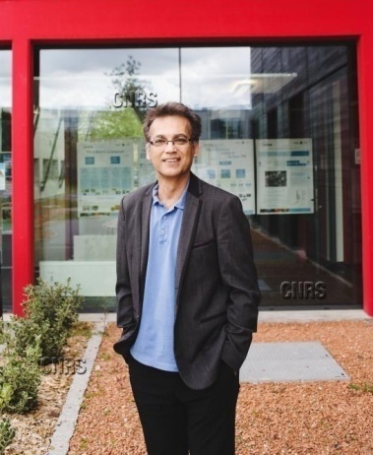
by Professor Ali Zolghadri,
Senior Member, IEEE IMS-CNRS lab - A31 building,
University of Bordeaux, 351 cours de la Libération,
33405 Talence cedex, France

12:30-13:00
Coffee Break

Conference Room A'

Time: 13.00-13:20
The lifetime cancer risk assessment of inhalation of PM-bound carcinogenic components in urban environments
by Constantinos Sioutas, Vahid Jalali Farahani, Mohammad Aldekheel

Time: 13.20-13:40
A Case Study about Innovative Engineering Education based on Capacitor Charging and Discharging in Circuits & Systems
by Hua Fan

Time: 13.40-14:00
The Spectral Characteristics of f-waves - the Prognostic Significance of Atrial Fibrilation Recurrences after Ablation
by Mikhail Matveev, Iskren Garvanski, Vessela Krasteva, Todor Stoyanov

Time: 14.00-14:20
Hazardous Industrial Waste In The European Union
by Nivolianiti Zoi

Time: 14.20-14:40
Numerical analysis of the interaction of Savonius vertical axis wind turbines in tree-type cluster configuration
by Mihnea Gall, Ion Mălăel, Dragoș Preda

Time: 14.40-15:00
Time Series Satellite Data for Assessment of Urban Air Pollution and Climate Dynamics impacts on COVID-19 transmission in Bucharest
by Dan Savastru, Maria A. Zoran, Roxana Savastru, Marina N. Tautan, Daniel v. Tenciu

12:30-13:00
Coffee Break

Conference Room B'

Time: 13.00-13:20
Evaluation of Adaptive Synthetic Resampling Technique for Imbalanced Breast Cancer Identification
by Tsehay Admassu Assegie, Ayodeji Olalekan Salau

Time: 13.20-13:40
Positioning technique in the XY plane based on circle approximation for wafer stage control
by Seongjin Oh, Jongpil Jeong, Chae-gyu Lee, Tae-yong Kim, Yongju Na, Se-hyeon Ryu

Time: 13.40-14:00
The Spectral Characteristics of f-waves - the Prognostic Significance of Atrial Fibrilation Recurrences after Ablation
by Mikhail Matveev, Iskren Garvanski, Vessela Krasteva, Todor Stoyanov

Time: 14.00-14:20
Hazardous Industrial Waste In The European Union
by Nivolianiti Zoi

Time: 14.20-14:40
Numerical analysis of the interaction of Savonius vertical axis wind turbines in tree-type cluster configuration
by Mihnea Gall, Ion Mălăel, Dragoș Preda

Time: 14.40-15:00
Time Series Satellite Data for Assessment of Urban Air Pollution and Climate Dynamics impacts on COVID-19 transmission in Bucharest
by Dan Savastru, Maria A. Zoran, Roxana Savastru, Marina N. Tautan, Daniel v. Tenciu

15:00-15:30
Coffee Break

Conference Room A'

Time: 15.30-15:50
Numerical and Experimental Anaysis of Massive MIMO Channel Characteristics in a Rectangular Highway Tunnel at 5.9 GHz
by Esteban Egea-Lopez, Jose-Maria Molina-Garcia-Pardo, Martine Lienard, Pierre Laly, Pierre Degauque

Time: 15.50-16:10
Limitations and perspectives of the Multi Beam Optical FBMC Technology in Optical Fiber Communications
by Rastislav Róka

Time: 16.10-16:30
The Use of Constructive Simulation in the Educational Process of Military Engineers
by Ota Rolenec, Martin Vlkovsky, Martin Sedlacek

Time: 16.30-16:50
Auto-tuning method for alternating aeration control in activated sludge processes
by Ioana Nascu, Ioan Nascu

Time: 16.50-17:10
Design of Monolithic RF CMOS Sub-mW Self-Oscillating-Mixers
by S. Fenni, F. Haddad, A. Slimane, R. Touhami and W. Rahajandraibe

Time: 17.10-17:30
Costas Loop for BPSK Carrier Phase Synchronisation Implemented on a SDR Hardware Platform
by Ryan D Amato, Ivan Grech, Owen Qasha

Time: 17.30-17:50
Communication of innovation: focus on Georgian SMEs
by Velga Vevere, Ketevan Rizhamadze, Iveta Linina

Time: 17.50-18:10
A Fast Transient, 24 mA Switched Capacitor Boost Regulator in 40 nm CMOS Technology
by Mostafa Hosny, Sameh Ibrahim

Time: 18.10-18:30
A Swarm-Based Flocking Control Algorithm for Exploration and Coverage of Unknown Environments
by Fredy Martı́nez, Angélica Rendón, Fernando Martı́nez

Time: 18.30-18:50
A Machine-Learning Approach for Prognosis of Oscillating Water Column Wave Generators
by Izaskun Garrido, Jon Lecube, Fares Mzoughi, Payam Aboutalebi, Irfan Ahmad, Salvador Cayuela, Aitor Garrido

Time: 18.50-19:10
Strategy development for use of influencers in communication of small and medium-sized enterprises (SMEs) with consumers
by Iveta Linina

15:00-15:30
Coffee Break

Conference Room B'

Time: 15.30-15:50
Pattern Wafer x/y Auto Align System using Machine Vision
by Tae-yong Kim, Jongpil Jeong, Chae-gyu Lee, Seongjin Oh, Lee Jieun, Yongju Na

Time: 15.50-16:10
Design and Implementation of an Ellipsometer Inspection System that Conforms to the Wafer s MI Process in the Production Process
by Jae-Sung Kim

Time: 16.10-16:30
Software for animation and graphic visualization of mechatronic elements and control process of FMS
by Mammadov Javanshir, Huseynov Agil, Aliyeva Sabina, Khuliyeva Ulviya, Aliyeva Hadiya

Time: 16.30-16:50
Study of Voltage controlled oscillator for the applications in K-band and the proposal of a tunable VCO
by Garima Kapur, Rajnu Parashar

Time: 16.50-17:10
Nano-Education at the Crossroads: How to Engage Ukrainian Youth in Nanotechnology Specialties?
by Ihor Bohdanov, Hanna Lopatina, Anastasia Popova, Natalia Tsybuliak, Sergii Kovachov, Yana Suchikova

Time: 17.10-17:30
High-Quality Digital Bichronous Education for Nanoengineers During the War in Ukraine: Does Technology Knowledge Matter?
by Anastasia Popova, Natalia Tsybuliak, Sergii Kovachov, Yana Suchikova, Hanna Lopatina, Ihor Bohdanov

Time: 17.30-17:50
Towards Leveraging Explainable Artificial Intelligent (XAL) in Requirements Engineering (RE) to Identify Aspect (Crosscutting Concern): A Systematic Literature Review (SLR) and Bibliometric Analysis
by Aws A. Magableh

Time: 17.50-18:10
Identification and Prevention of Banking Fraud and Scams
by Farhad Mehdipour, Evgenii Babenkov, U.H.W.A. Hewage, Ari Aharari

Time: 18.10-18:30
Multi-microgrids system’s resilience enhancement
by Samira Chalah, Hadjira Belaidi

Time: 18.30-18:50
Modeling Malaria Disease Spread Using Location-specific Internet Data
by Gbenga Adegbite, Sunday Edeki, Itunuoluwa Isewon, Jelili Oyelade, Ezekiel Adebiyi

20:00-24:00
BANQUET. Greek Night with Live Music and Folklore Dances from Rhodes (Rodos), Crete and other Greek Islands.

Additional Banquet Tickets for accompanying Persons: 35 EUR
BANQUET will be held on July 19 in DROSOULITES
https://www.tripadvisor.com.gr/Restaurant_Review-g635613-d7715450-Reviews-Drosoulites_Rakadiko-Rhodes_Town_Rhodes_Dodecanese_South_Aegean.html
in a walking distance from the Hotel Mediterranean

CONFERENCE PROGRAMME
HOTEL MEDITERRANEAN
35 - 37, Cos Str., Rhodes Island, 85100, Greece
Tel.: 0030 22410 24661, 0030 22410 97000
www.mediterranean.gr E-mail: info@mediterranean.gr

Thursday, July 20, 2023

09.00-16:00 (working hours of the Secretariat)
Registration
Distribution of the Conference bags
* Certifications of Presentation and Receipts (Invoices) will be sent to you only by email

Conference Room A'

Time: 08.00-08:20
Design and implementation of a voice assistant to be used in a IoT home automation environment
by Sergio Yahel Torres-Maldonado, David Tinoco-Varela, Raúl Dalí Cruz-Morales, Gonzalo Hedain López-Mera, Diego Sánchez-García, Erick Axel Padilla-García

Time: 08.20-08:40
Flying Carpets: Assessing Artificial Intelligence as an Entertainment Service
by Theodoros Anagnostopoulos

Time: 08.40-09:00
Remote Temparature and Humidity Measurement System for home and warehouses
by Stanyo Kolev

Time: 09.00-09:20
Digitalization of Entrepreneurship Education: In Search Of A New Approach
by Kristaps Lesinskis

Time: 09.20-09:40
The fuzzy model for sectoral resilience analysis
by Nedosekin A., Malyukov Yu., Abdoulaeva Z., Silakov A.
Time: 09:40-10:00
Carbon Pricing in Germany’s Road Transport and Housing Sector: Options for Reimbursing Carbon Revenues
by Manuel Frondel, Stefanie Schubert

Time: 10.00-10:20
Net Zero Policy Performance Measurement of European Countries
by Rana Duygu Alkurt, Mehtap Dursun, Nazli Goker

Time: 10.20-10:40
Narrowband Internet of Things (NB-IoT) for Energy Efficient Body Area Network (BAN) Applications
by Emil Novakov

Time: 10.40-11:00
Determination of Flame Plume Characteristics utlising CFD and Experimental Approaches
by Neihad Hussen Al-Khalidy

Time: 11.00-11:20
Student Learning Styles in Information Technology
by Sussy Bayona Oré
Time: 11.20-11:40
Geomorphological and Sedimentological Indicators of Contemporary Erosion Processes: An Example of the Eastern Rhodopes Mountains (Bulgaria)
by Valentina Nikolova, Radostina Rizova, Veselina Gospodinova, Asparuh Kamburov

11:40-12:00
Coffee Break

Conference Room B'

Time: 09.00-09:20
Scale-dependent statistical analysis of hydrogeological parameters
by Paola Gattinoni

Time: 09.20-09:40
Time Series Satellite and Observational Data for Assessment of Urban Air Pollution and Climate Dynamics Impacts on COVID-19 transmission in Bucharest
by Dan Savastru, Maria a. Zoran, Roxana Savastru, Marina N. Tautan, Daniel V. Tenciu
Time: 09:40-10:00
Spatiotemporal changes of urban land surface albedo impact on thermal environment in Bucharest metropolitan city
by Maria A. Zoran, Roxana Savastru, Dan Savastru, Marina n. Tautan, Adrian c. Penache

Time: 10.00-10:20
Comprehensive study of Wheat Yield Prediction using Analytical and Simulation Approaches
by Nandini Babbar

Time: 10.20-10:40
Ultrasonic pretreatment for Enhancing Sludge disintegration and Resource Utilization: A mini review
by Ziliang Guan

Time: 10.40-11:00
Determination of Flame Plume Characteristics utlising CFD and Experimental Approaches
by Neihad Hussen Al-Khalidy

Time: 11.00-11:20
Preliminary date of ground water characteristics and related disease risk
by Raafat Abdeldayem
Time: 11.20-11:40
About the Tikhonov Regularization Method for the Solution of Incorrect Problems
by V.M.Ryabov, I.G.Burova

11:40-12:00
Coffee Break

Conference Room A'

Time: 12.00-12:20
Appropriate communication of the strategy as an impact factor for business model digitalization
by Rosita Zvirgzdina

Time: 12.20-12:40
Realtime Detection of Table Objects and Text Areas for OCR Preprocessing
by Hangseo Choi, Jongpil Jeong
Time: 12:40-13:00
Container BIC-Code Recognition Algorithm Based on the Convergence of a 1-Stage Detector and a 2-Stage Detector
by Hangseo Choi, Jongpil Jeong, Seokwoo Yun, Kyunga Bang, Jaebeom Byun

Time: 13.00-13:20
Small-signal and Transient Stability Investigation of Inverter Grid Synchronization
by Alexander Schöley, Torsten Jeinsch

Time: 13.20-13:40
Extraction of TRMM Satellite Data for rain fall prediction
by Krachache Zahia, Ayoub Atmane, Sarah Benziane

Time: 14.40-14:20
The use of biometric technologies to increase security at sporting events
by Barbora Kotkova

Time: 14.20-14:40
Design and Development of a Multifunction Device for Lead Acid Batteries
by Lubomír Macků, František Gazdoš, Martin Hlavizna
Time: 14.40-15:00
The dynamic model of the real integrating process with variable coefficients
by Miroslav Palka, Frantisek Gazdos

15:00-15:20
Coffee Break

Conference Room B'

Time: 12.00-12:20
Use of Dynamic Biometric Signature in Communication of Company
by Barbora Kotkova

Time: 12.20-12:40
Multi-microgrids system’s resilience enhancement
by Samira Chalah, Hadjira Belaidi
Time: 12:40-13:00
The Microsystem Design of Steering Angle Sensor
by Hua Fan

Time: 13.00-13:20
Application of Splines of the Seventh Order Approximation to the Solution of Fredholm Integral Equations with Weekly Singularity
by I.G.burova, G.O.Alcybeev

Time: 13.20-13:40
Basic CMOS VLSI Circuits and Low Power Devices Employing Various Reduction Techniques to Reduce Leakage Power at Low Supply Voltage in Nanoscale Technology
by GHanshyam Singh

Time: 14.40-14:20
Kolb Model: Learning Styles of Engineering Students
by Sussy Bayona Oré

Time: 14.20-14:40
Bearing Fault Diagnosis of WDCNN-LSTM in Siamese Network
by Daehwan Lee, Jongpil Jeong, Chaegyu Lee, Hakjun Moon, Jaeuk Lee and Dongyoung Lee

15:00-15:20
Coffee Break

Conference Room A'

Time: 15.20-16:00
Pre-trained CNN-based TransUNet Model for Mixed-Type Defects in Wafer Maps
by Youngjae Kim, Jee-Hyong Lee, Jongpil Jeong

Time: 16.00-16:20
Extracting a Mathematical Model from Oil Drilling Data using GMDH
by Amir Mohammad, Reggie Davidrajuh

Time: 16.20-16:40
Identification and Prevention of Banking Fraud and Scams
by Farhad Mehdipour, Evgenii Babenkov, U.H.W.A. Hewage, Ari Aharari

Time: 16.40-17:00
Control Principles of Stationary Articulated Robots Used in Cyber-Physical Factories
by Květoslav Belda, Lukáš Venkrbec

Time: 17.00-17:40
A Linear Algebraic Toolbox for Analyzing Strongly Connected Components
by Reggie Davidrajuh

Time: 17:40-18:00
Particle Swarm Optimisation for Model Predictive Control Adaptation
by Květoslav Belda, Lenka Kuklišová Pavelková

Time: 18.00-18:20
Deep Learning Electric Load Forecasting for the Greek Power System
by Vasileios Zelios, Paris Mastorocostas, George Kandilogiannakis, Anastasios Kesidis, Panagiota Tselenti, Athanasios Voulodimos

Time: 18.20-18:40
Topological Deformation Learning: Nonlinear Dimension Reduction by Autonomous Evolving of Data Manifold
by Xiaodong Zhuang, Nikos Mastorakis

CONFERENCE PROGRAMME
HOTEL MEDITERRANEAN
35 - 37, Cos Str., Rhodes Island, 85100, Greece
Tel.: 0030 22410 24661, 0030 22410 97000
www.mediterranean.gr E-mail: info@mediterranean.gr

Friday, July 21, 2023

09.00-16:00 (working hours of the Secretariat)
Registration
Distribution of the Conference bags
* Certifications of Presentation and Receipts (Invoices) will be sent to you only by email

Conference Room A'

Time: 08.00-08:20
Prevention of Transmission of Infections in Robotic Milking
by Dimitar Karastoyanov, Elena Blagoeva, Kancho Peychev, Gencho Valchev

Time: 08.20-08:40
Monitoring the movement of people and tracking contacts in medical facilities
by Katarína Kampová, Martin Boroš, Matúš Madleňák, Erika Skypálová

Time: 08.40-09:00
Development of the Ishikawa diagram of sensory projections
by Eva Brlek, Lovorka Gotal Dmitrović

Time: 09.00-09:20
On Move-To-Front Implementation
by Borut Žalik, Mitja Žalik, Bogdan Lipuš

Time: 09.20-09:40
A Sample Model for Integrating Decentralized Payment Systems Through Common Gateway for E-commerce
by Vadims Zilnieks, Ingars Erins
Time: 09:40-10:00
Solution of Stochastic Sine-Gordon Equation by Variational Iteration Method
by Haziem M. Hazaimeh

Time: 10.00-10:20
Control of Additive Manufacturing Process Based on FEM Analysis to Increase Productivity and Component Strength
by Miloš Matúš, Peter Križan, Miroslava Švecová, Stanislav Strigáč, Ján Kijovský, Juraj Beniak

Time: 10.20-10:40
A vertical systematic generalization towards real IP analog-mixed-signal AMS schematics structure recognition
by Mohamed Salem, Ali Deeb, Abdalrahman Ibrahim,Witesyavwirwa Vianney Kambale, Pichler Joachim, Fadi Al Machot, Kyandoghere Kyamakya

Time: 10.40-11:00
Data Classification Analysis for Alzheimer Disease Diagnostic
by Virginia Valcheva, Olga Georgieva

Time: 11.00-11:20
Ensemble Transfer Learning for Time Series Forecasting: a Sensitivity Analysis framework for a Shallow Neural Network
by Witesyavwirwa Vianney Kambale, Ali Deeb, Taha Bernabia, Fadi Al Machot, Kyandoghere Kyamakya
Time: 11.20-11:40
Transformers in Time Series Forecasting: A brief Transfer Learning Performance Analysis
by Witesyavwirwa Vianney Kambale, David Krame Kadurha, Ali Deeb, Fadi Al Machot, Taha Bernabia, Kyandoghere Kyamakya

Time: 11.40-12:00
Automatie classification of a full-thickness macular hole in optical coherence tomography images
by Jakob Wasserman, Andrzej Dziech, Remigiusz Haran, Michael Windisch, Jakub Wojniak, Pawel Domin

12:00-12:20
Coffee Break

Conference Room B'

Time: 09.00-09:20
A critical survey on wireless network for achieving the QoS for video transmission.
by Pundalik Chavan

Time: 09.20-09:40
Telemetry of Coal Miners Using Smart Jacket
By Vanitha U, Aakaash V S, Arvinth R A, Ashwin T, Bhagavathidharshan B
Time: 09:40-10:00
An Euclidean Jordan Algebra of Symmetric Matrices Closed for the Schur Product
By Luis Vieira

Time: 10.00-10:20
Artificial Intelligence and Mentoring: Inferring dropout and managing mentoring
by Bruno Silva, Eduardo Pires, António Paulino, João Barroso, Arsénio Reis

Time: 10.20-10:40
Controlling the polarization of segmentelectrics while increasing the specific power and specific energy of the powertrain to increase the idle speed and reduce the charging time of electric vehicles
by Vladimir Zubtsov

Time: 10.40-11:00
Timely detection of diabetes with SVM, Neural Network and Deep Neural Network
by Rumen Valchev, Miroslav Nikolov, Ognyan Nakov, Milena Lazarova, Valeri Mladenov

12:00-12:20
Coffee Break

Conference Room A'

Time: 12.20-12:40
Particle Accelerators and Gamma-Therapeutic Devices - an Effective Tool for Cancer Treatment
by Vladimir Krasilnikov, Eduard Kuplennikovч
Time: 12:40-13:00
Comparison of K-means, K-means++, X-means and Single Value Decomposition for Image Compression
by Krista Rizman Žalik, Mitja Žalik

Time: 13.00-13:20
Artificial Dataset Generation for Modeling and Simulation of Shared Electric Automated and Connected Mobility Systems with Autonomous Repositioning: A Survey
by Antoine Kayisu Kazadi, Witesyavwirwa Vianney Kambale, Taha Bernabia, Ali Deeb, Pitshou Bokoro, Kyandoghere Kyamakya

Time: 13.20-13:40
Assessing How Large Language Models can be Integrated with or Used for Blockchain Technology : Overview and Illustrative Case Study
by Jean Gilbert Mbula Mboma, Obed Tshimanga Tshipata, Witesyavwirwa Vianney Kambale, Kyandoghere Kyamakya

Time: 13.40-14:00
Automatic Detection of Defective Metal Pressed Components Using Artificial Intelligence
by Ari Aharari, Kaoru Inaba, Farhad Mehdipour

Time: 14.00-14:20
Quantitative Management of Business Disbursements by Portfolio Optimization
by Todor Stoilov, Krasimira Stoilova
Time: 14.20-14:40
Optimization Models for Urban Traffic Management
by Krasimira Stoilova, Todor Stoilov

Time: 14.40-15:00
A Boxplot Metadata Configuration Impact on Time Series Forecasting and Transfer Learning
by Witesyavwirwa Vianney Kambale,Ali Deeb,Taha Bernabia,Fadi Al Machot, Kyandoghere Kyamakya

Time: 15.00-15:20
Production of Parts from Metal Powder - Advanced Technologies
by Dimitar Karastoyanov, Todor Penchev, Vladimir Monov

15:20-15:50
Coffee Break

Conference Room B'

Time: 12.20-12:40
A New Method of Image Steganography Technique Based On Fingerprint With Qr-Code Using Watermarking Technique
by Manoj Kumar Sharma, Nidhi Bansal, Suraj Malik, Gaurav Kumar
Time: 12:40-13:00
Development Arena through Cloud Computing Technology
by Nidhi Bansal, Suraj Malik, Gaurav Kumar, Manoj kumar Sharma

Time: 13.00-13:20
Application of Splines of the Seventh Order Approximation to the Solution of Fredholm Integral Equations with Weekly Singularity
by I.G.burova, G.O.Alcybeev

Time: 13.20-13:40
Basic CMOS VLSI Circuits and Low Power Devices Employing Various Reduction Techniques to Reduce Leakage Power at Low Supply Voltage in Nanoscale Technology
by GHanshyam Singh

Time: 14.40-14:20
Kolb Model: Learning Styles of Engineering Students
by Sussy Bayona Oré

Time: 14.20-14:40
Bearing Fault Diagnosis of WDCNN-LSTM in Siamese Network
by Daehwan Lee, Jongpil Jeong, Chaegyu Lee, Hakjun Moon, Jaeuk Lee and Dongyoung Lee
Time: 14.40-15:00
Timely detection of diabetes with SVM, Neural Network and Deep Neural Network
by Rumen Valchev, Miroslav Nikolov, Ognyan Nakov, Milena Lazarova, Valeri Mladenov

Time: 15.00-15:20
Drug Dosage Computing System for Control of Anaesthetic and Hemodynamic Variable
by UMAMAHESWARI.K

15:20-15:50
Coffee Break

CONFERENCE PROGRAMME
HOTEL MEDITERRANEAN
35 - 37, Cos Str., Rhodes Island, 85100, Greece
Tel.: 0030 22410 24661, 0030 22410 97000
www.mediterranean.gr E-mail: info@mediterranean.gr

Saturday, July 22, 2023

Conference Excursion

The Following Articles will be presented electronically and will be posted here https://www.interbit-research.com/presentations.html

Title | Authors
Conversion of Atmospheric Carbone Dioxide into Minerals at Room Conditions Using the Sea Water with Various Additives | Muthana AL-Gburi
Realtime Detection of Table Objects and Text Areas for OCR Preprocessing | Hangseo choi, jongpil jeong
Container BIC-Code Recognition Algorithm Based on the Convergence of a 1-Stage Detector and a 2-Stage Detector | Hangseo choi, jongpil jeong, seokwoo yun, kyunga bang, jaebeom byun
Microfinance Digitalization and Its Perception by Citizens in Kosovo | Shpresim Vranovci
Fighting Crime with CNN-Based Image Processing: A Study on Signature Forgery Detect | Ossama H. Embarak1, Maryam Almesmari , Maryam Alameeri , Fatima Aldarmaki
“Review Paper on Prediction of Transmission Network Congestion using AI Techniques” | Sandeep A. Kale, Dr. Nitin D. Ghawghawe
Gaussian Location Mixtures | Miguel Felgueiras, João Martins, Rui Santos
A Machine-Learning Approach for Prognosis of Oscillating Water Column Wave Generators | Izaskun Garrido, Jon Lecube, Fares Mzoughi, Payam Aboutalebi, Irfan Ahmad, Salvador Cayuela, Aitor Garrido
Implementation And Risk Of Management Application In The Field Of Innovation And Entrepreneurship | Besnik Hajdari
Relational analysis between‘Activity’ and ‘Effort’ as Quantitative Parameters of Software Projects | Ekbal Rashid
The Challenges with Implementation and Security of Next-Generation (6G) Networks | Parvinder Singh, Pardeep Kumar
Effect Of A Specially Pulsed Magnetic Field On Wound Healing In Rat Skin | Selcuk Comlekci
Ordering of small parameters in nonlinear wave problems | Georgy I. Burde
The influence of different seed positions on mechanical properties of stochastic structures with semi-controlled nodes | Inga Krešić, Jasmin Kaljun, Nebojša Rašović
Human Resources Strategies & Lessons Learned During the COVID-19 Pandemic: A Literature Review | Queenie c. Plater, marquise d. Frazier, patricia y. Talbert, vivian h. Davis, payton s. Talbert
A continuum space is the infinitely great | Qing Li
Critical Discourse Analysis of the Cyberlanguage used by Libyan Adolescents | Nadia Nuseir
On the new properties of conditional expectations and sequences of predicted random variables | Ismihan Bayramoglu
Towards The Preparation Of Quality Foundation Phase Teachers In The University: The Attitude And Improvisation Skills Of First Year Students | Lulama Aletta Kahla
Resource Allocations Using Complete Graphs for D2D Communications | Tsang-Ling Sheu and Yen-Chieh Chiu
Topology: from pure mathematics to applications in mathematical physics, to engineering sciences and to data analysis | Philippe Durand
A review of Deep Learning Techniques and application for Image Captioning | Amruta R. Chougale
Study of Voltage controlled oscillator for the applications in K-band and the proposal of a tunable VCO | Garima kapur, Rajni Parashar
Environmental management - methodology and efficiency | Nadia Marinova
Corporate governance models and mechanisms | Nadia Marinova
Network Behaviour Monitoring using Deep Learning Technique | Mohd Nazri Ismail
An approximation modeling approach for 3D elasto-plastic stress-strain analysis of notched components under general multiaxial cyclic loadings | Ayhan Ince
Named Entity Recognition: A survey of Indian Languages | Seema Shukla, V N Shukla
Network Behaviour Monitoring using Deep Learning Technique | Mohd Nazri Ismail
A Comparative Study of Bipolar and Unipolar Control for Single-Phase Asynchronous Motors: SimPower System MATLAB Analysis and RTLAB Validation | Fezazi Omar, Ayad Ahmed Nour El Islam, Hasan Köten

