Plenary Lecture

Extended Unbiased FIR Filtering for Indoor Robot Self-Localization

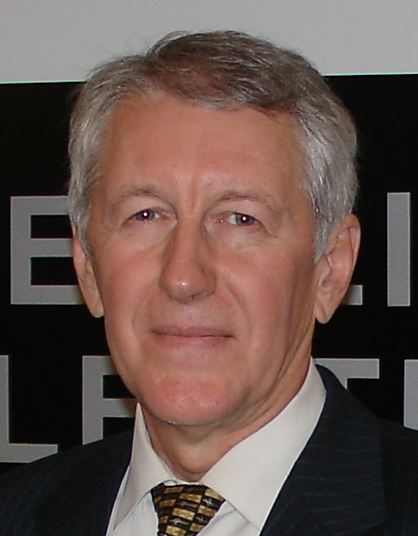

Professor Yuriy S. Shmaliy
Department of Electronics Engineering
DICIS, Universidad de Guanajuato,
Salamanca, 36885, Mexico
E-mail: shmaliy@ugto.mx

Abstract: Mobil robot self-localization in diverse environments is a key problem for many industrial applications. We consider a novel estimation technique called extended unbiased finite impulse response (EFIR) filtering which has several advantages against the traditional extended Kalman filter (EKF): better robustness against uncertainties, lower sensitivity to noise, and smaller round-off errors. A fast iterative EFIR localization algorithm utilizing recursions is discussed as a rival to the EKF. Unlike the EKF, the EFIR filter completely ignores the noise statistics. Instead, it requires an optimal horizon of N_{opt} points in order for the localization performance to be acceptably suboptimal. It is shown that N_{opt} can be specialized via measurements with much smaller efforts and cost than for the noise statistics required by the EKF. Overall, EFIR filtering is more successful in accuracy than the EKF under the uncertain conditions. Extensive investigations of the approach are conducted in applications to indoor mobile robot self-localization via triangulation and in radio frequency identification (RFID) tag grid environments. Better performance of the EFIR filter is demonstrated when the noise statistics are not known exactly. As a special inference, it is shows that the EKF diverges not only due to large nonlinearities and large noise as was previously known from the Kalman filter theory, but also due to errors in the imprecisely defined noise statistics. In contrast, the EFIR filter does not demonstrate divergence in this case.
Brief Biography of the Speaker:
Dr. Yuriy S. Shmaliy has been a full professor in Electrical Engineering of the Universidad de Guanajuato, Mexico, since 1999. He received the B.S., M.S., and Ph.D. degrees in 1974, 1976 and 1982, respectively, from the Kharkiv Aviation Institute, Ukraine. In 1992 he received the Dr.Sc. (technical) degree from the Soviet Union Government. In March 1985, he joined the Kharkiv Military University. He serves as full professor beginning in 1986 and has a Certificate of Professor from the Ukrainian Government in 1993. In 1993, he founded and, by 2001, had been a director of the Scientific Center “Sichron” (Kharkiv, Ukraine) working in the field of precise time and frequency. His books Continuous-Time Signals (2006) and Continuous-Time Systems (2007) were published by Springer, New York. His book GPS-based Optimal FIR Filtering of Clock Models (2009) was published by Nova Science Publ., New York. He also edited a book Probability: Interpretation, Theory and Applications (Nova Science Publ., New York, 2012) and contributed to several books with invited chapters. Dr. Shmaliy has authored more than 300 Journal and Conference papers and 80 patents. He is IEEE Fellow; was rewarded a title, Honorary Radio Engineer of the USSR, in 1991; and was listed in Outstanding People of the 20th Century, Cambridge, England in 1999. He currently serves on the Editorial Boards of several International Journals and is a member of the Program Committees of various Int. Symposia. His current interests include statistical signal processing, optimal estimation, and stochastic system theory.

